**Assignment 06**

**Hierarchical clustering – Single Link**

Name: Puja Kawale

SJSUID: 0125-06156

Date: 10/18/2018

Personal Notes:

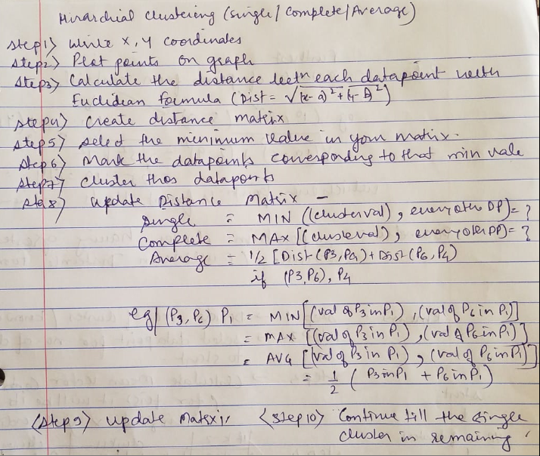

**Screenshots of the manual calculations done:**

